| **Test Name** | Automated Operations: Tank Level Sensor Turns Pump On |
| --- | --- |
| **Use Case Tested:** | Tank Level Sensor Turns Pump On |
| **Test Description:** | This test verifies the business rules automatically start the pump when the tank water level drops to the low-level threshold. |
| **Pre-conditions** | * Pump not running * Dashboard state of pump: not running. * ThingsBoard has not asked the pump to start running via manual operation. * Automatic control is enabled. * The “switch pump on when tank level is below” field is set to 1 metres. * The current tank level is greater than 1 metre. |
| **Post-conditions** | * The pump controller has switched the pump on. * AUTOMATIC Pump On message has been added to pump events log. |
| **Notes:** |  |

|  | **TEST STEP** | **EXPECTED TEST RESULTS** |
| --- | --- | --- |
|  | Use Simulator to send tank sensor message with level 1.0 metres | * An AUTOMATIC ON event is listed in the event log. * A downlink is scheduled with payload 03 xx yy where xx yy is the hex value of the estimated fill timer. * Dashboard state sync indicator shows yellow. |
|  | Command the pump controller to send a status message. | * Downlink Command will be received by pump controller. * Pump controller switches pump on, LED on feather lights up. * Pump controller sends a status message with pumpRunning: 1 * Dashboard Running LED will switch to green. * Dashboard state sync indicator shows green. * Dashboard on/off switch is in the on state. |

|  |  |  |  |  |  |
| --- | --- | --- | --- | --- | --- |
| **Test Data Table** | | | | | |
|  | **1** | **2** | **3** | **4** | **5** |
| [Data field 1] | [data set 1 input value for field 1] |  |  |  |  |
| [Data field 2] | [data set 1 input value for field 2] |  |  |  |  |
| [Data field 3] | [data set 1 input value for field 3] |  |  |  |  |

**Results**

26/08/2020

**Failed.**

Initial failure was due to Water Level Check rules chain bugs due to changes in water level sensor field names and device relations. Fixed those.

Still failed because the pump on message sent to the controller did not include a timer value set to the current estimated fill time. The last line has the binary payload and it is 01 not the expected 03 00 78.

19:57:23.634 -> rpcRequest: v1/devices/me/rpc/request/348 - 69 - {"method":"ignored","params":{"runPump":1,"timerOn":false,"timer":0}}  
19:57:23.634 -> Received op = ignored, running = 1, timerFlag = 0, timeout = 0  
19:57:23.634 -> Encoded command:  
19:57:23.634 -> 01

Dashboard on/off switch did not switch to on.

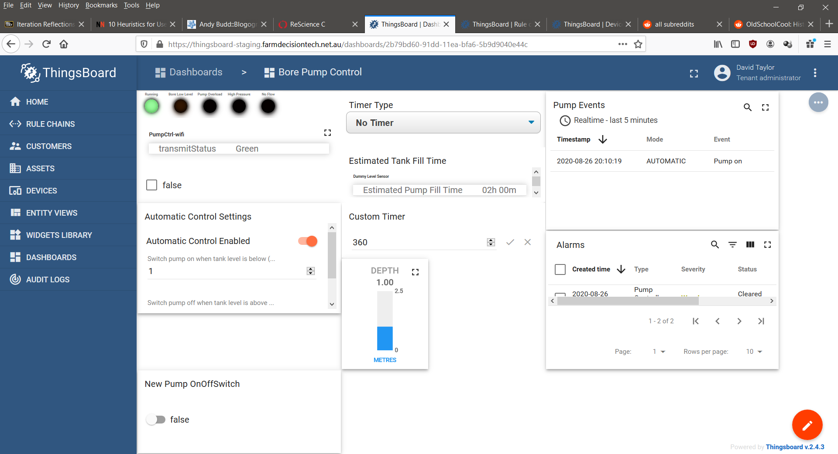

02/09/2020

**Success.**

Fixed rule chain to use the Requested state flag to trigger turning on/off the pump.

Fixed Relationship between wifi controller and dummy sensor.

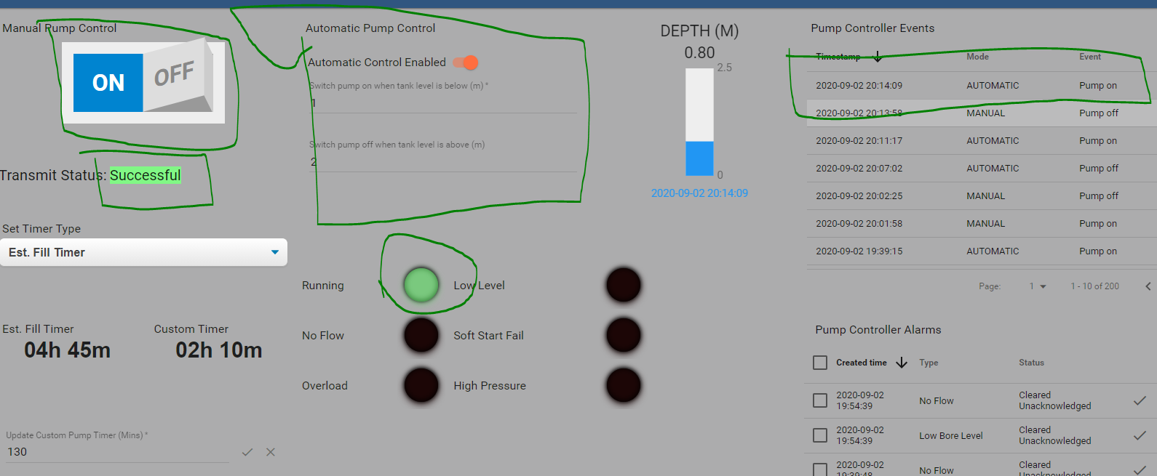

9/9/2020 – On site test at OAI.

Success.

Step 1.

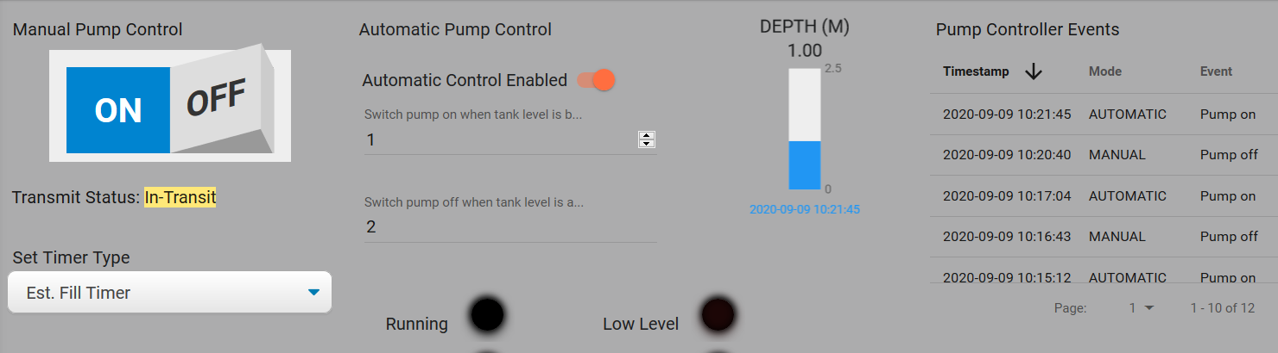

Step 2.

10:23:04.443 -> LoRaWAN will encode and send this message: {'pumpRunning':0,'boreLowLevel':0,'softStartFail':0,'pumpOverload':0,'controllerRestart':0,'highPressure':0,'noFlow':0}

10:23:04.443 -> Sending status byte: 00

10:23:05.510 -> EV_TXCOMPLETE (includes waiting for RX windows)

10:23:05.510 -> Received reply with 3 bytes:

10:23:05.510 -> 03 00 85

10:23:05.510 -> callback got data 3

10:23:05.510 -> Switched pump on.

10:23:05.510 -> Starting one-shot timer.

10:23:05.510 -> Timer in minutes: 133

10:23:05.548 -> Sending status due to state change.

10:23:05.548 -> LoRaWAN will encode and send this message: {'pumpRunning':1,'boreLowLevel':0,'softStartFail':0,'pumpOverload':0,'controllerRestart':0,'highPressure':0,'noFlow':0}

10:23:05.548 -> Sending status byte: 01

10:23:11.159 -> EV_TXCOMPLETE (includes waiting for RX windows)

